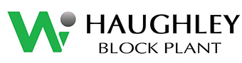

Carbon Reduction Plan

November 2023

Commitment to achieving net zero.
Haughley Block Plant Ltd is committed to achieving net zero emissions by 2030 at the least.

Baseline emissions footprint.
Baseline year: 2022
Our baseline emissions inventory includes all our measurable Scope 1, 2 and 3 emissions.
We include all 7 Kyoto Protocol Greenhouse Gas groups in our emissions footprint calculations.
Baseline year emissions:
Emissions Total t CO²
Scope 1 129.72
Scope 2- market- based. 0.00
Scope 3 2,960.61
Total Emissions 3,090.33 T

Emissions reduction targets:

We have committed to reaching a Net Zero by 2030 and have submitted a target, the progress against this target can be seen in the graph adjacent:
Figures for 2023 are calculated mid-term and are valid as of Nov 2023 (incl.)

Carbon Reduction Projects:
Completed carbon reduction initiatives:
- Our environmental management system is UKAS certified to ISO 14001:2015
- We procure certified 100% renewable electricity for the company manufacturing and office/ admin processes.
- LED lights are procured for the whole business operations.
- The whole manufacturing process is powered by renewable energy.
- Almost all factory plant is electrical.
- We procured factory crusher to reduce transportation of waste concrete blocks to recycling centre and recycle the blocks in-house.
- We have 0% landfill waste concrete blocks.
- We introduced lightwell blocks, which consume less fuel to transport to our final clients.
- We use strapping which has 98% recycled content.
- We procure our timber pallets from sustainable and reputable sources and repair pallets where viable to reduce deforestation.
- We have procured newer fleet vehicles to meet the emissions standards in London.

- Solar panels installed to further eliminate grid maintenance associated emissions.
Planned carbon reduction initiatives:
- Incorporate BES 6001 principles within the existing environmental and quality management systems, to meet the criteria and achieve a minimum of a recognition of a Very Good sustainable supplier as a minimum.
- Investigate the possibility of transitioning from diesel fuel to HVO fuel for all internal fleet vehicles.
- Promote HVO fuel among suppliers and actively engage with all supply chain to encourage alternative fuel types.
- Continue crushing defect blocks internally to eliminate the emissions during transportation of waste.
- We will engage with our supply chain and promote BES 6001 across all aggregate suppliers.
- We will attend conferences to maintain our knowledge on technological progress and updates.
- We will invest in green initiatives

Factory Energy Use Per Block:

Haughley Block Plant Ltd is committed to fully monitor and track its energy consumption and actively seeking to reduce the kilowatts used per manufactured block by using its electrical plant and machinery as well as welfare units sensibly and promoting initiatives which will further reduce our energy consumption.
Haughley Block Plant Ltd are proud to be using green energy for in factory facilities and for all supporting administrative processes. We are committed to continue using green energy until our solar panels are fully installed and operational.

This is to ensure that all grid associated carbon emissions are eliminated by using in-house solar panels.
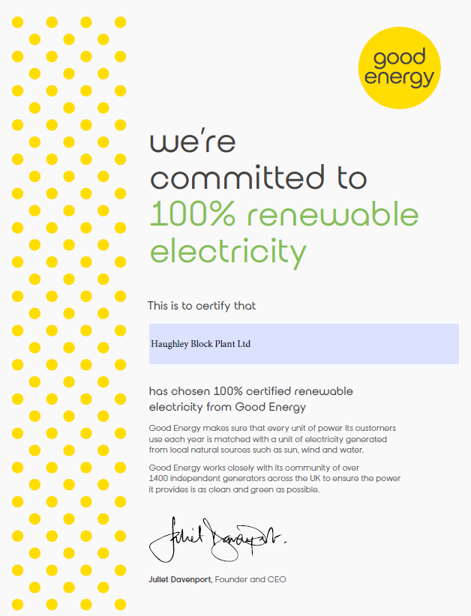

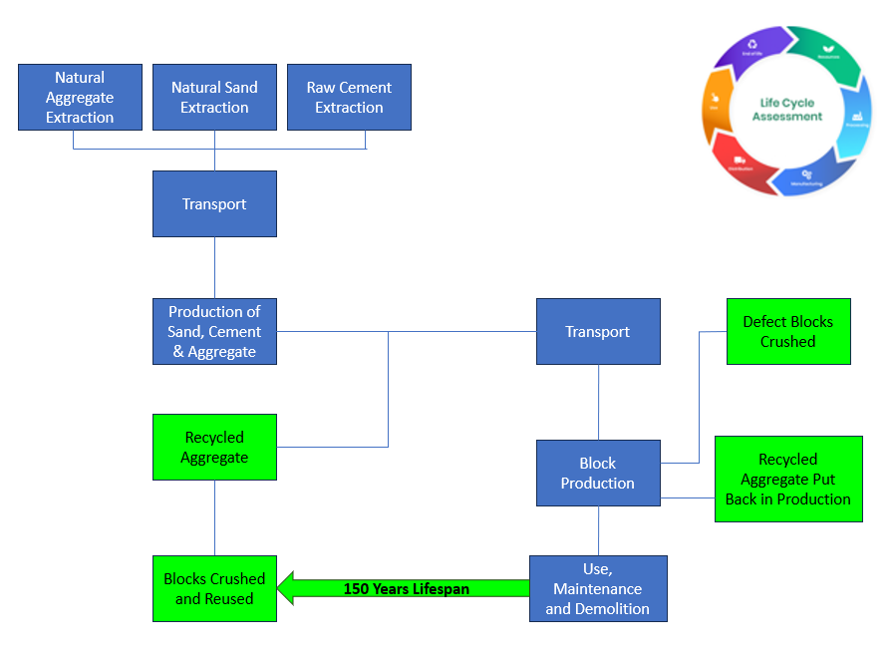
Life Cycle Assessment of Concrete Blocks

Waste Reduction Targets
Haughley Block Plant Ltd invested in block crushers so that all blocks, which do not meet our highest quality expectations, are crushed within our factory premises and subsequent aggregate is put back in production.
The above practice eliminates all transportation of waste materials and its associated carbon emissions.
Haughley Block Plant Ltd has been tracking its waste since 2022 and our charts are as follows:

For both 2022 and 2023 to date HBP has met its internal targets
Water Use and Reduction Targets

Haughley Block Plant Ltd.’s purpose is “bringing resources to life”. The sustainable use of natural capital, that is our natural assets including rivers, oceans, forests, resources, minerals, and land, is fundamentally important to all of us.
Our business depends on water, and we are focused on providing and using water in the most efficient and sustainable way possible.

We have measured our water usage per manufactured block and will ensure that figures are reduced with every year to come until we achieve our mission to completely eliminate the need to use grid water supply and adjust our mix recipes in such a way that rainwater tanks will be sufficient for the whole of the manufacturing process in our factory.

Transportation Environmental Reduction Policy

At Haughley Block Plant Ltd we recognize that transport has environmental impacts- these can arise from delivering services or distributing goods and products to clients and staff travelling to and from work. A green transport policy sets out the organization’s aims and intentions to reduce those impacts and improve transport performance overall.
We will seek to minimize the environmental impact of our delivery and distribution operations by:
- Maximizing the efficiency of our transportation routes through improved logistics and flexible delivery methods
- Incorporating environmental performance objectives into all transport operations including the use of ecofriendly efficient fuels such as HVO
- Maintaining all fleet vehicles to higher than minimum standards
- Ensuring transport movements in and out of our facilities are optimized and consistent with general traffic movements and noise levels.
- Training employees, including haulers, in safe and efficient driving programs
- Moving to a new vehicles and energy sources as soon as operationally and functionally viable
- Working with suppliers and contractors to support our green transport policies.

Human Rights and Modern Slavery Policy

Although my company does not fall under the requirements of the Modern Slavery Act 2015 (Turnover less than £36 Million) I am committed to ensuring acts of modern-day slavery and human trafficking will never be an issue within my company and its External Providers, including sub-contractors, and partners.

I will ensure that there is full transparency within my company and our External Providers of goods and services to the organisation.

As part of my company’s due diligence processes into slavery and human trafficking the External Provider approval process will incorporate a review of the controls undertaken by the External Provider whenever the External Provider falls under the requirements of the Modern Slavery Act.

Imported goods from sources from outside the UK and EU are potentially more at risk for slavery/human trafficking issues. The level of management control required for these sources will be continually monitored.

I will not permit my company to support or deal with any business knowingly involved in slavery or human trafficking. My Directors and Senior Management Team shall take responsibility for implementing this policy statement and its objectives and shall provide when deemed necessary adequate resources (training, etc.) and investment to ensure that slavery and human trafficking is not taking place within the organisation and within its External Providers.

A copy of this policy will be made available and briefed to all of our Employees with a copy of the Modern Slavery Act 2015 held within the Legislation Register and available to all employees upon request.

This Policy takes into account and supports, the policies, procedures and requirements documented in our Integrated Management System, which is compliant with the requirements of ISO 9001:2015, ISO 14001:2015 and ISO 45001 :2018

Formal procedures concerning slavery and human trafficking will be established, when required including disciplinary procedures where the requirements of the Act have been identified as being breached.

I will ensure that this policy is communicated to and understood by all of my employees and where necessary our External Service Providers. It is included within the Management Review Process to ensure its continuing suitability and relevance to the company activities and status.

Declaration and sign off:

This Carbon Reduction Plan has been completed in accordance with PPN 06/21and associated guidance and reporting standards for Carbon Reduction Plans.

Emissions have been reported and recorded in accordance with the published reporting standards for Carbon Reduction Plans and the GHG Protocol Corporate Accounting and reporting Standard and used the most relevant emissions factors sourced from government and official environmental bodies and suppliers.
Scope 1 and Scope 2 emissions have been reported in accordance with SECR requirements, and the required subset of Scope 3 emissions have been reported in accordance with the published reporting standard for Carbon Reduction Plans and the Corporate Value Chain (Scope 3) Standard.
To ensure the reporting of Scope 3 emissions is achievable and realistic figures are worked with, HBP calculated the emissions of embodied transport, embodied materials, and waste calculations. Scope 3 emissions related to general maintenance, inspection visits and non-frequent factory related transportation is not taken into consideration.

This Carbon Reduction Plan has been reviewed and signed off by the Managing Director of Haughley Block Plant:

Signed on behalf of Haughley Block Plant Ltd:
Liam Clear/ Director

Date: November 2023

Document References:

file:///C:/Users/Teodora.Todorova/Downloads/secr_explained.pdf
https://gosupercritical.com/downloads/secr_explained.pdf
https://gosupercritical.com/downloads/secr-explained?utm_term=secr%20reporting%20guidance&utm_campaign=SECR+-+Reporting&utm_source=adwords&utm_medium=ppc&hsa_acc=7860535262&hsa_cam=20239473060&hsa_grp=150593525683&hsa_ad=664733361352&hsa_src=g&hsa_tgt=kwd-786605667353&hsa_kw=secr%20reporting%20guidance&hsa_mt=p&hsa_net=adwords&hsa_ver=3&gclid=Cj0KCQjw2eilBhCCARIsAG0Pf8tNvlCevFt2GvbcN5lbH7sulpXcoZZmjwfiWbEbIJWivZTMqW4gcSQaAkpeEAL

